Cloud Deployment Documents

**Introduction to Cloud Computing:**

Cloud computing has been described as an innovation in computing architecture whose central characteristic is the virtualization of computing resources and services. Cloud computing allows computing resources to be delivered with five central attributes: as an on-demand service; with infinite and rapid elasticity and scalability; on a measured basis (meaning the service can be billed); through pooled (i.e., shared) resources; and with broad network access.

**Introduction to Cloud Computing in Manufacturing Unit:**

As industrial automation becomes more intelligent and manufacturers embrace machine-to-machine (M2M) technology, cloud computing is set to become the obvious solution to store and manage the ever-growing expanse of production data. Aside from increased storage space, the cloud helps manufacturers to reduce costs, change business models, provide new services, increase agility, optimise performance and ultimately, drive profitability.

**Our Requirement:**

Currently our system is running on intranet and we want to migrate the Application as Internet based application and also we are keeping the database server under our own maintains division.

We need to migrate the Database as well as our application to Cloud. We need to host all the application and their database to cloud.

Below is the Database details.

|  |  |  |  |  |  |  |  |
| --- | --- | --- | --- | --- | --- | --- | --- |
| **S.N** | **Database Server** | **Database Type** | **RAM** | **O/S** | **Storage** | **No of Database** | **Remarks** |
| 1 | Production Server | SQL Server 2012 | 64 GB | Windows Server 2008 R2 | 100 GB | 1)LoginDB 2)TransactionDB 3)SessionManagement DB | Currently its working on our Internet |
| 2 | Staging Server | SQL Server 2012 | 32 GB | Windows Server 2008 R2 | 100 GB | 1)LoginDB 2)TransactionDB 3)SessionManagement DB | Currently it’s working on our Internet. We need to create Staging Server on Cloud as well. |
| 3 | DR Server | SQL Server 2012 |  |  | Same as Prodction | 1)LoginDB 2)TransactionDB 3)SessionManagement DB | Currently there is no DR Server for our database we need to make a DR Server on Cloud as well |
| 4 | Production Server | SQL Server 2012 Reporting Services | 16 GB | Windows Server 2008 R2 | 50 GB |  |  |

We will be also Hosting our Application on Cloud.

Web Hosting Details.

|  |  |  |  |  |  |
| --- | --- | --- | --- | --- | --- |
| **S.No** | **Web Server** | **Application Details** | **Storage** | **O/S** | **Remarks** |
| 1 | Production Server | ASP.Net MVC 4.0 | 50GB | Windows Server 2008 R2 |  |
| 2 | Staging Server | ASP.Net MVC 4.0 | 10GB | Windows Server 2008 R2 | Same as production |
| 3 | DR Server | ASP.Net MVC 4.0 | 50 GB |  | Same as Production |

We need to host the SQL Server on different Server and Web Deployment on other Server.

Our Requirement:

1. SQL Server 2012 and above with at least 100 GB Space
2. SQL Reporting Services for Reporting
3. DR Server
4. Load balancing for the Application
5. Staging Environment on Cloud
6. Replica of Database.

Below are Models we need to discuss and need to know the best Cloud Architecture for our application on AWS Cloud. There would be some changes in the Model below as per our requirement and our need.

Model 1: Redundant 3-layer DataCenter

Any production environment that is launched in the cloud should also have a redundant architecture for failover and recovery purposes. Typically, you will use a Server Array for your application tier to take advantage of autoscaling in the cloud, however there may be some scenarios where your application is not designed to autoscale. In such cases, you can still create a redundant multi-tier architecture where you have redundancy at each tier of your reference architecture. In the example below, there are two load balancer servers, two application servers, as well as master and slave database servers. A redundant architecture will help protect your site/application from system downtime.

This example diagram also demonstrates the use of a striped volume set at the database tier. If your database is large and requires faster backups, you may consider using a set of striped volumes for data storage.

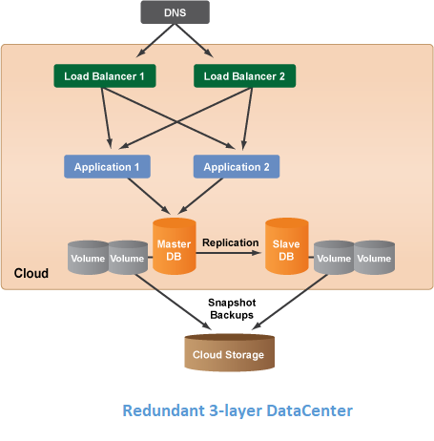

Model 2: Multi-Datacenter Architecture

If your cloud infrastructure supports multiple datacenters (or zones), it's recommended that you spread your system architecture across multiple datacenters to add another layer of redundancy and protection. Each datacenter in a cloud is designed to be an isolated segment inside the same geographical cloud. So if a power failure occurs in one datacenter, the other datacenters will be unaffected. For example, within a cloud/region there may be several resource pools called availability zones and datacenters. The benefit of using multiple datacenters is to protect your entire site/application from being negatively affected by some type of network/power failure, lack of available resources, or service outtage that's specific to a particular datacenter.

As a best practice you should always leverage multiple datacenters in your reference architecture if they are supported by the cloud infrastructure. In the other reference architecture diagrams below, it's also recommended that you use multiple datacenters even though it's not explicitly shown in the diagrams.

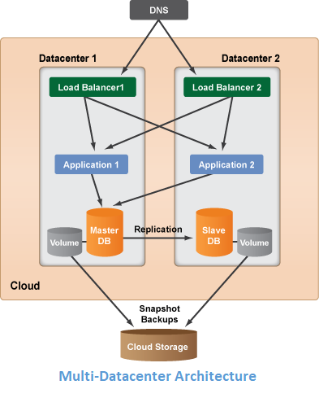

Model 3: Auto scaling Architecture

One of the key benefits of the cloud is the ability to horizontally scale (i.e. grow or shrink the number of running server resources) as the demands of your application/site change over time. With RightScale, you can use Server Arrays to set up a particular tier of your architecture to autoscale based on predefined alert conditions. Autoscaling is most commonly used for the application tier of your cloud reference architecture.

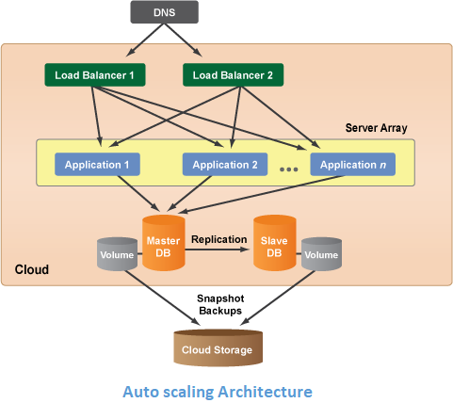

We need to know the roadmap for the migration on Cloud along with your cost and the also the cost which will be involved on AWS hardware and also we need all the security which we need to implement on the cloud server as well.

Hope this will work for the roadmap and also for the purpose for cost estimation.